Zahava Gopin

WEB 335: assignment 4.2

4/3/2023

Create a new database named web335DB with a collection named users. Take a screenshot and save it as an image.

Create a new custom role named web335Admin. Configure this role to the "Collection Actions" option. Take a screenshot and save it as an image.

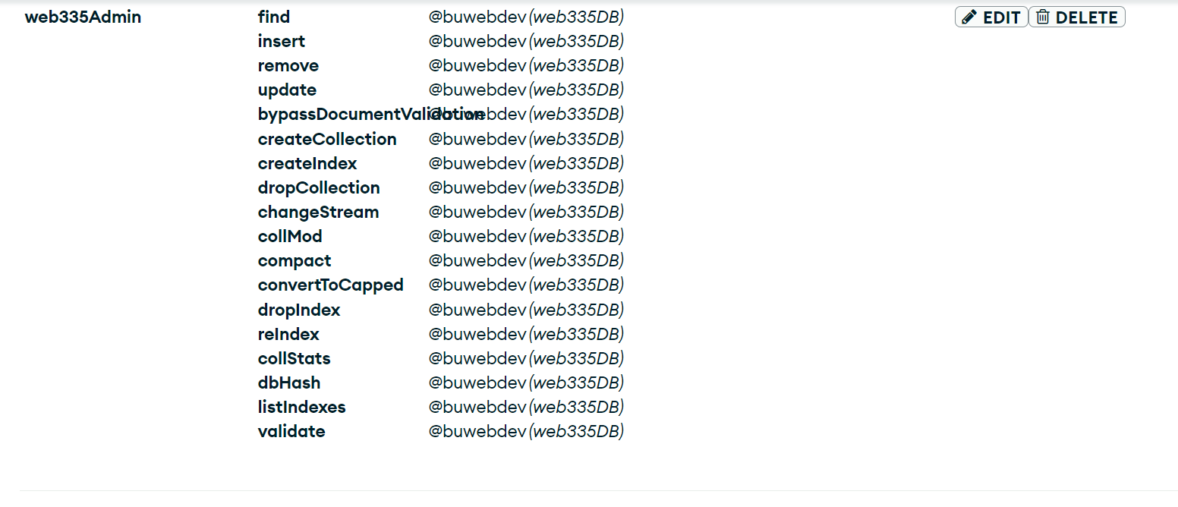

Create a new database user named web335_user with a password of s3cret and assign it the custom role web335Admin. Take a screenshot and save it as an image.

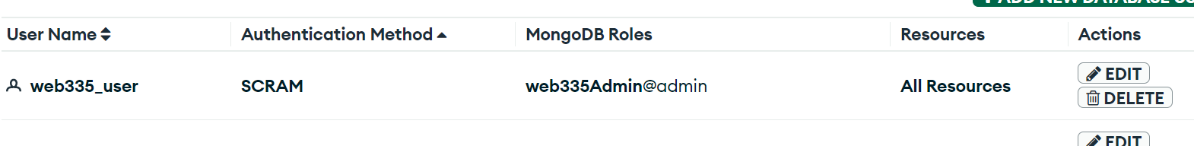

Download and install mongosh. Test the software's installation by running the command mongosh --help. Take a screenshot and save it as an image.

